The University of Azad Jammu and Kashmir, Muzaffarabad

Name: Alishba Zakir
Roll No: 2024-SE-02
Course: DataBase Systems
Course Code: CS-2204
Lab: 05
Submitted To: Engr. Awais Rathore
Submitted By: Alishba Zakir
Date: Mar, 2026

Department Of Software Engineering

Convert-2NF
2-NF:
The Rule of 2NF
A table is in 2NF if:
- It is already in 1NF.
- It has no partial dependencies.
A partial dependency happens when a non-prime attribute (a normal column) depends on only part of a composite primary key.
- Books-2NF:
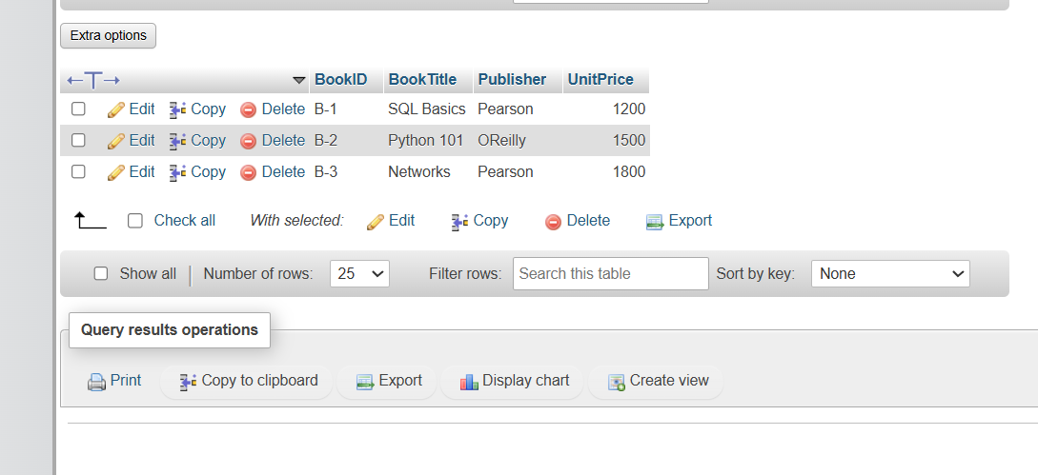
- Order_2NF:
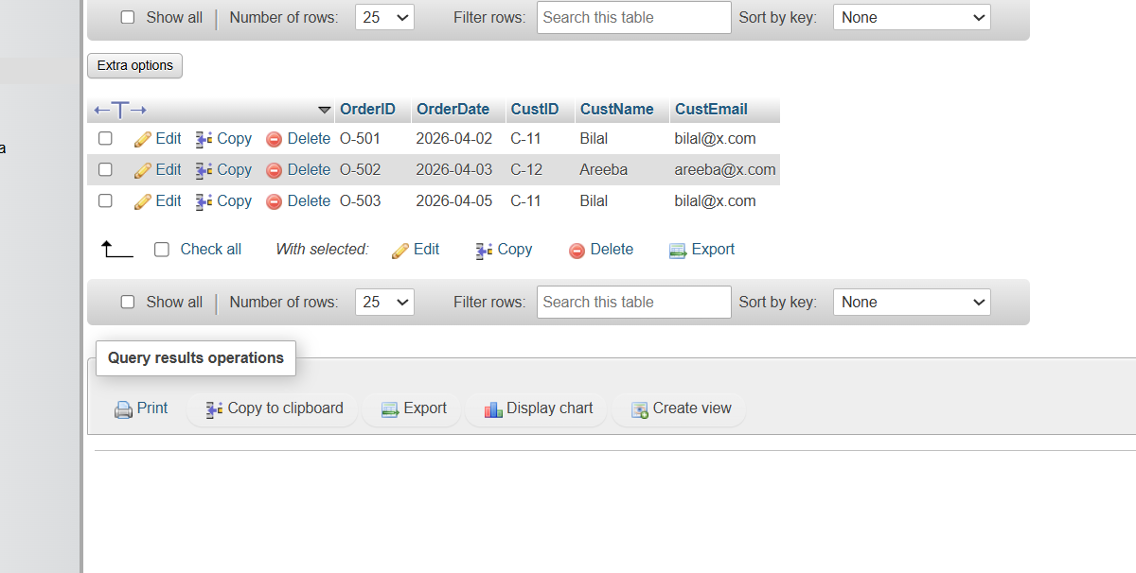
- OrderItem-2NF

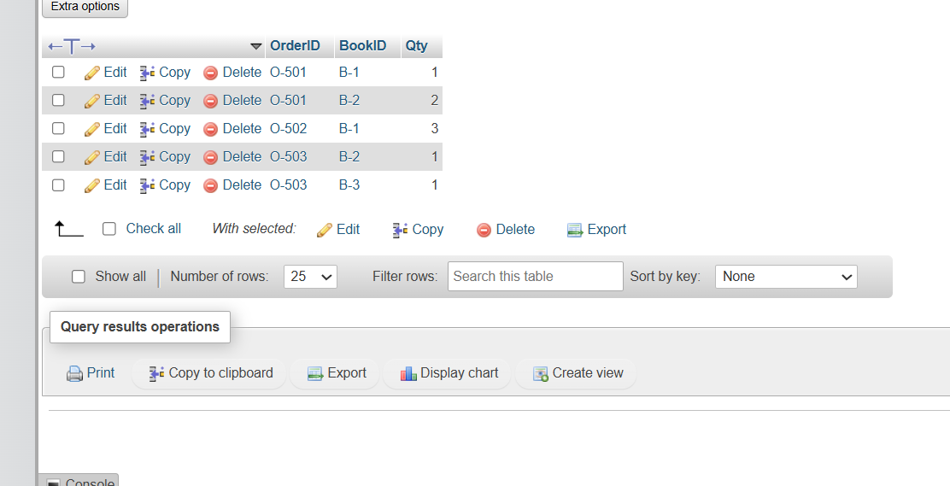
- Task 2 : 3-NF:
The Rule of 3NF
A database schema is in 3NF if:
- It is already in 2NF.
- It has no transitive dependencies.
Transitive Dependency Rule: A non-prime attribute (a normal column) must not depend on another non-prime attribute. Every attribute must depend on the primary key, the whole primary key, and nothing but the key.

Customer Table:

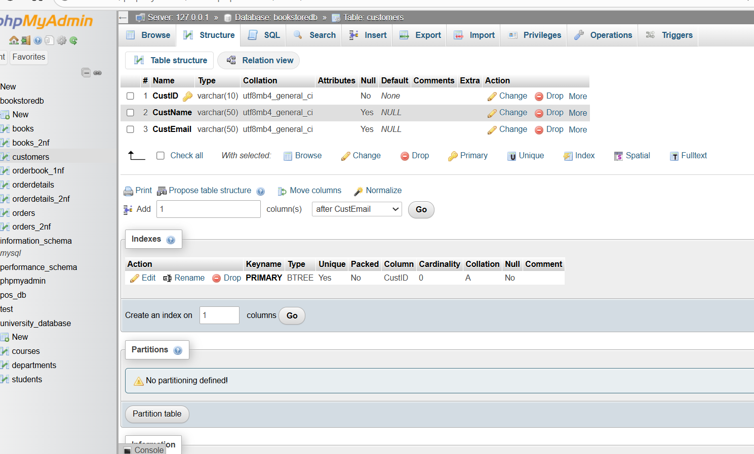

- OrderTable :
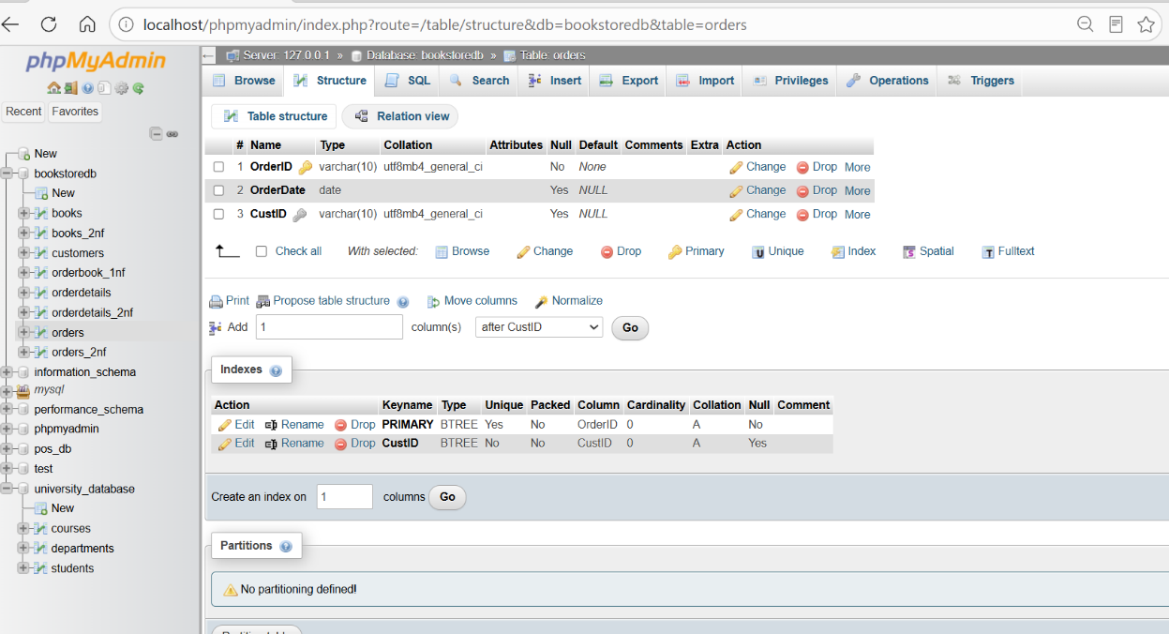
- BookTAble:
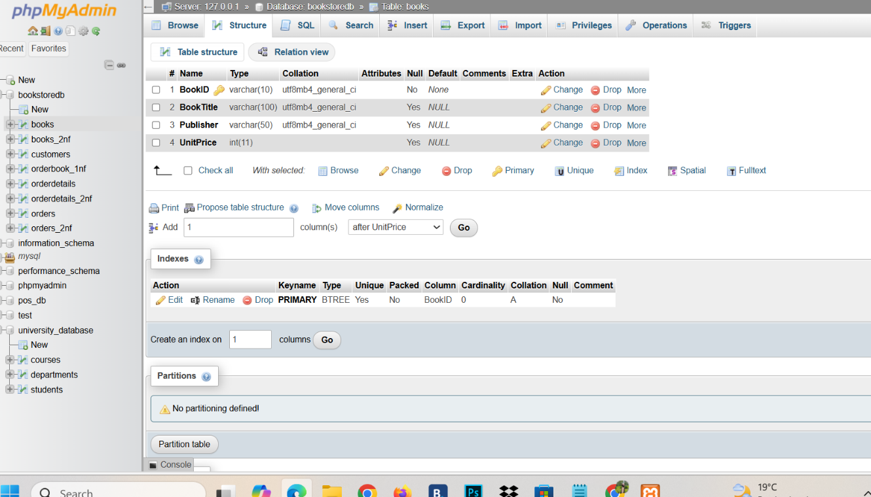
- Order_Item Table

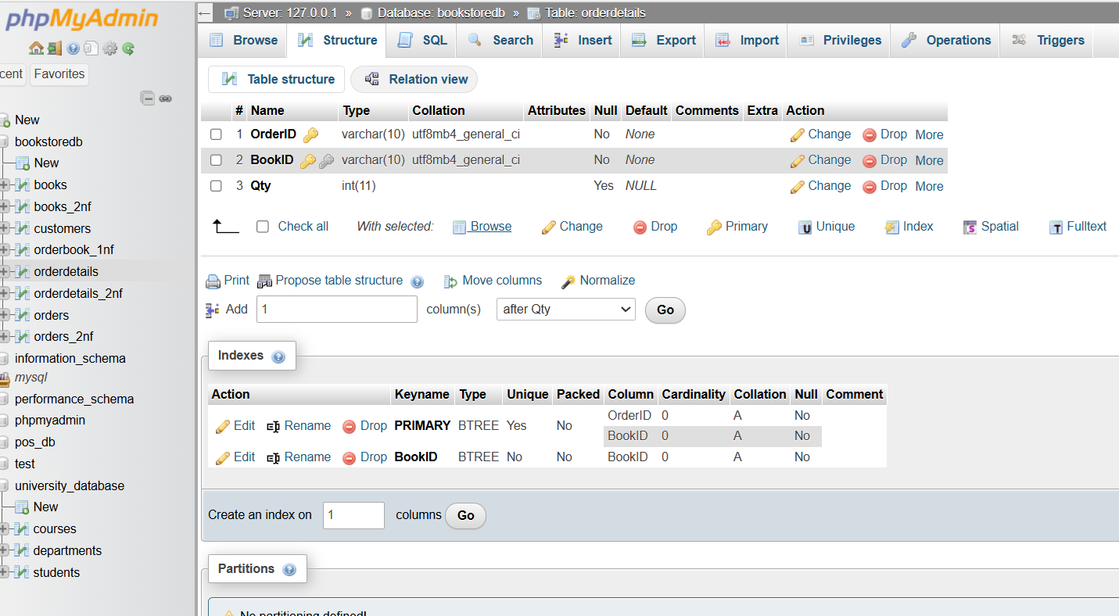

- Task4: verification Queries :
A verification query is a test script (usually using SELECT and JOIN statements) used to stitch decomposed tables back together.
- Why we use it: When you normalize a database, you break one big table into multiple small tables. The verification query reconstructs the original raw report to prove that no data was lost or corrupted during the split (lossless decomposition).

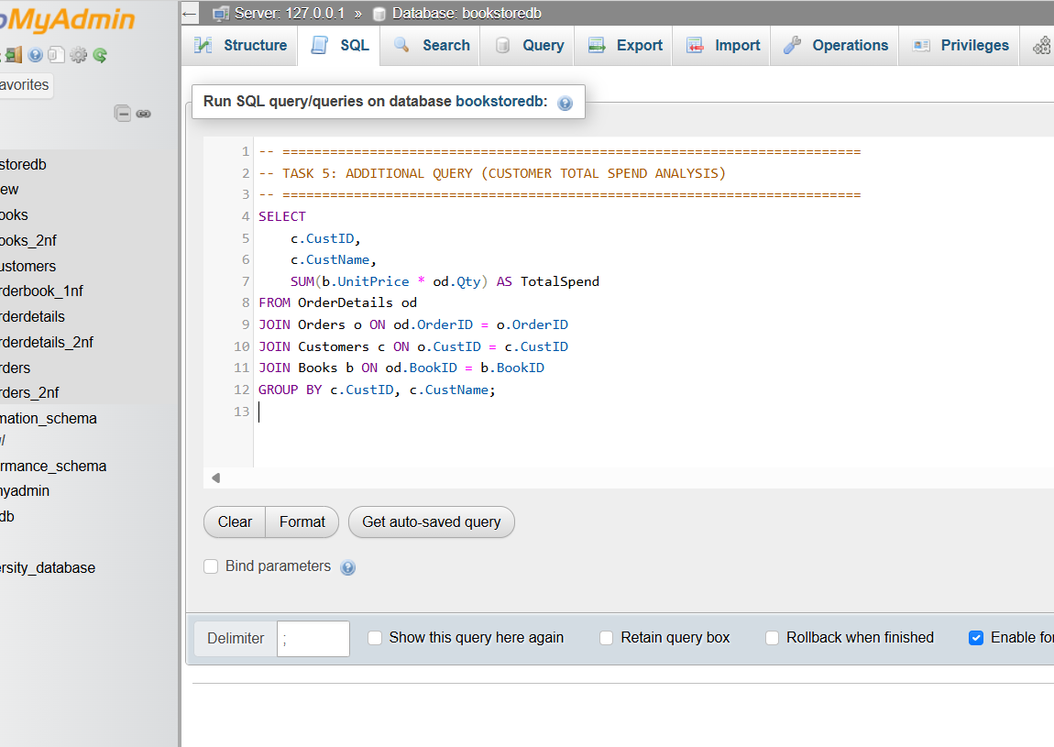

2. Database Reflection:
A database reflection is a short written justification (often added as comments at the end of an SQL file) explaining the engineering decisions made during design.
- Why we use it: It serves as documentation for developers or instructors. It explicitly proves how the new database structure successfully fixes partial or transitive dependencies and explains exactly which real-world data bugs (anomalies) the clean schema prevents.

